SEU/IS/19/ICT/046

NST31042

PRACTICAL FOR SCALING AND CONNENCTING

LABREPORT 12

**Title:** WAN - GRE Tunnel Configuration

Aim:

1. Configure and Familiar with DRE Tunnel

**Task:**

1. Configure GRE Tunnel
2. Configure OSPF

Q1

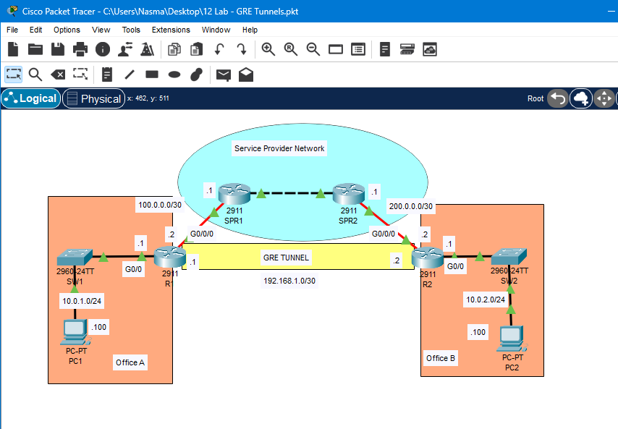

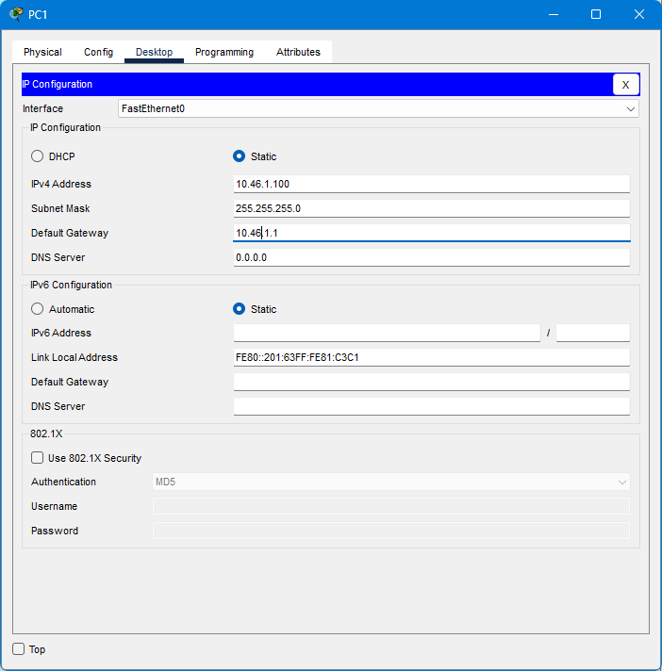

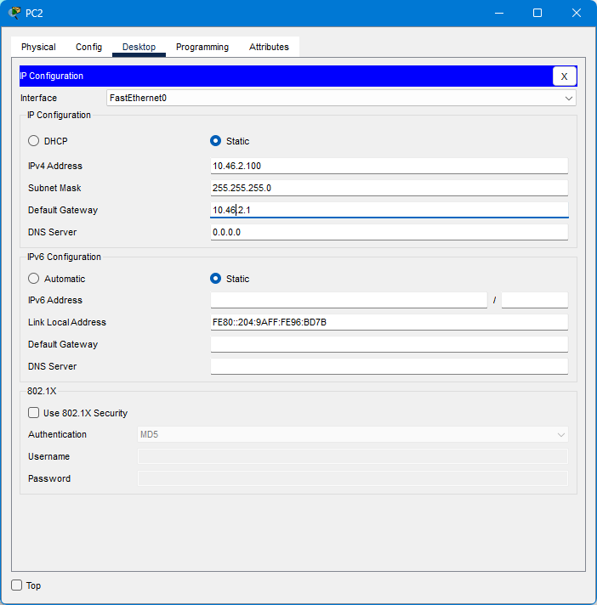

1. Configure a GRE tunnel to connect R1 and R2.

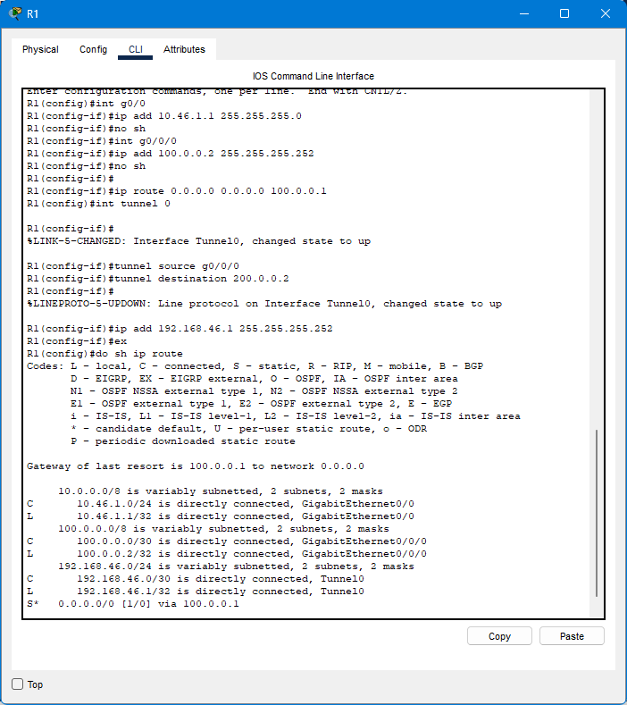

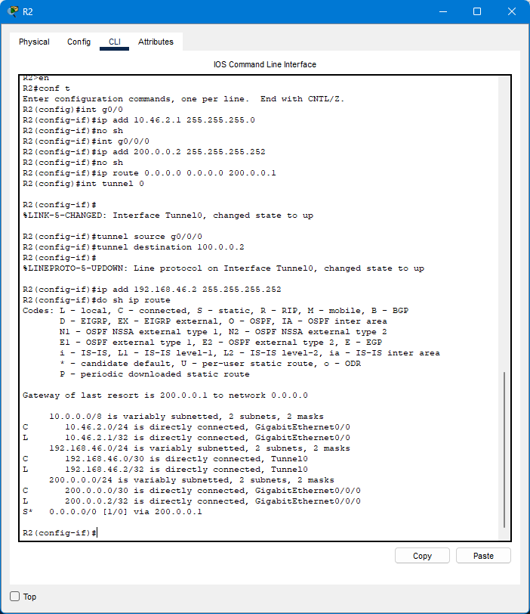

1. Configure OSPF on the tunnel interfaces of R1 and R2, to allow PC1 and PC2 to communicate.

**R1**

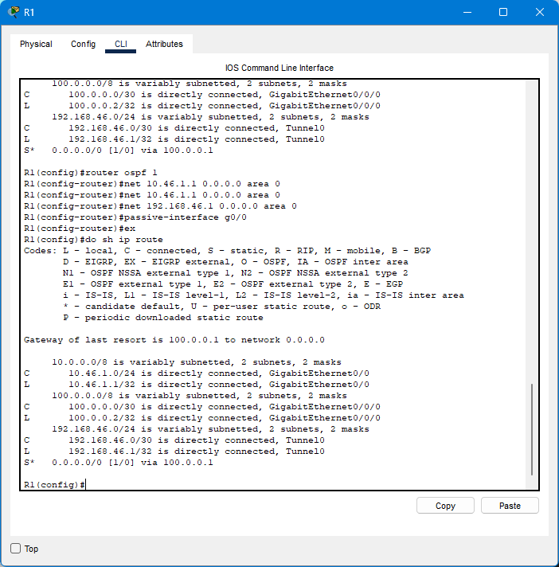

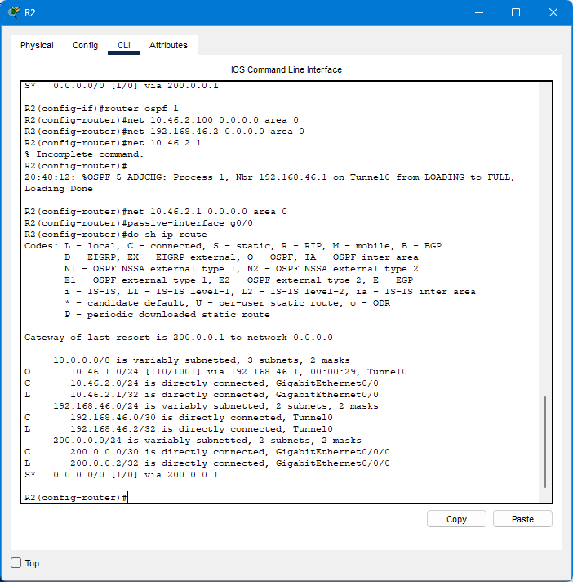

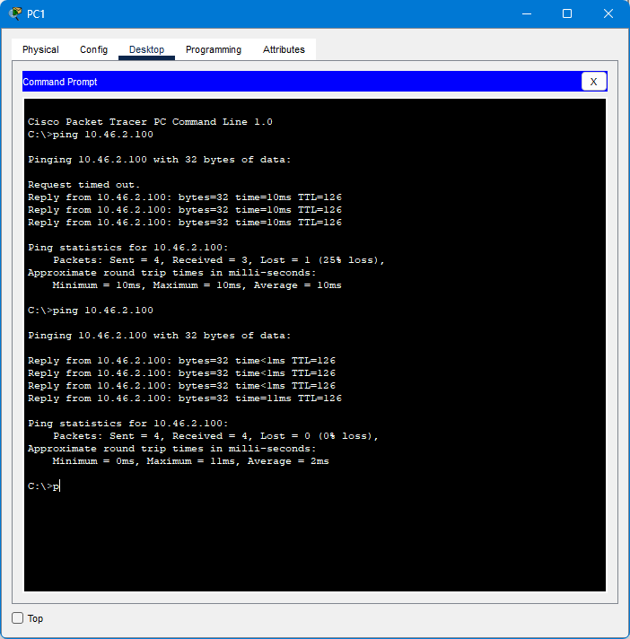

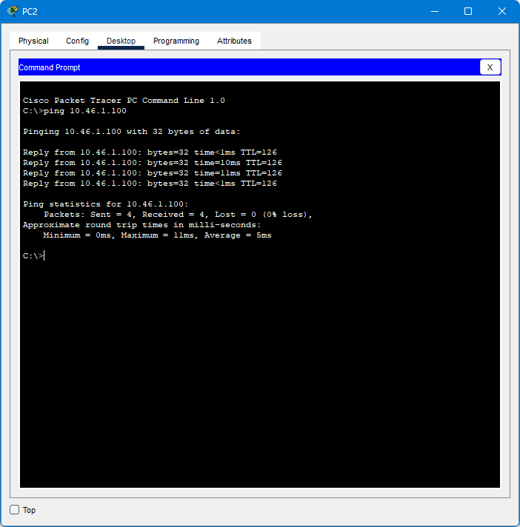

Discussion:

From this session only I have done without facing any trobles or errors

From this session I have learnt about the DRE tunnel and the functions of the tunnel.

Generic Routing Encapsulation (GRE) is a protocol that encapsulates packets in order to route various protocols over Internet Protocol (IP) networks. GRE is defined by Internet RFC 2784. GRE was developed as a tunneling tool meant to carry any OSI Layer 3 network protocol over an IP network

Reference:

<https://www.google.com/search?q=DRE+tunnel+in+netwok&oq=DRE+tunnel+in+netwok&gs_lcrp=EgZjaHJvbWUyBggAEEUYOTIJCAEQIRgKGKABMgkIAhAhGAoYoAHSAQoxODI4N2owajE1qAIIsAIB&sourceid=chrome&ie=UTF-8>